**SALES DATA ANALYSIS**

**Identifying KPIs**

1. **STATUS**

SELECT DISTINCT STATUS FROM sales_data;

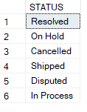

1. **PRODUCTLINE**

SELECT DISTINCT PRODUCTLINE FROM sales_data

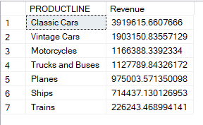

1. **COUNTRY**

SELECT DISTINCT COUNTRY FROM sales_data

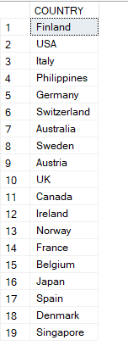

1. **DEALSIZE**

SELECT DISTINCT DEALSIZE FROM sales_data

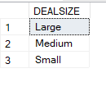

1. **TERRITORY**

SELECT DISTINCT TERRITORY FROM sales_data

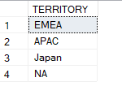

**ANALYSIS**

1. **PRODUCTLINE VS SALES REVENUE**

SELECT PRODUCTLINE, SUM(SALES) Revenue

FROM sales_data

GROUP BY PRODUCTLINE

ORDER BY 2 DESC



1. **YEAR VS SALES REVENUE**

SELECT YEAR_ID, SUM(SALES) Revenue

FROM sales_data

GROUP BY YEAR_ID

ORDER BY 2 DESC

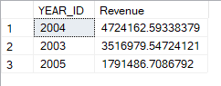

1. **WHY IS REVENUE OF 2005 LESS**

SELECT DISTINCT MONTH_ID FROM sales_data

WHERE YEAR_ID = 2005

ORDER BY MONTH_ID DESC

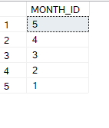

*They operated only for 5 months in the whole year of 2005*

1. **DEALSIZE VS REVENUE**

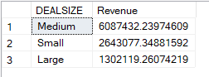

1. **BEST MONTH FOR SALES**

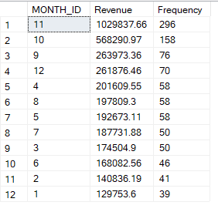

1. **BEST PRODUCT SOLD IN BEST MONTH FOR SALES**

select MONTH_ID, PRODUCTLINE, round(sum(sales),2) Revenue, count(ORDERNUMBER)

from sales_data

where YEAR_ID = 2004 and MONTH_ID = 11 --change year to see the rest

group by MONTH_ID, PRODUCTLINE

order by 3 desc

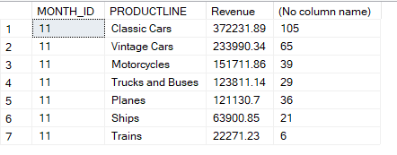

1. **CITY WITH HIGHEST NUMBER OF SALES IN A SPECIFIC COUNTRY**

select city, sum (sales) Revenue

from sales_data

where country = 'UK'

group by city

order by 2 desc

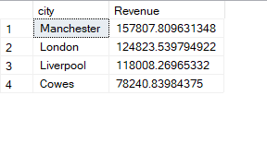

1. **BEST PRODUCT IN US**

select country, YEAR_ID, PRODUCTLINE, sum(sales) Revenue

from sales_data

where country = 'USA'

group by country, YEAR_ID, PRODUCTLINE

order by 4 desc

